Static and Final Keywords
The static keyword is used to create fields and methods that belong to the class, rather than to an instance of the class.
When several objects are created from the same class blueprint, they each have their distinct copies of instance variables. Each object has its values for these variables, stored in different memory locations.
Sometimes, you want to have variables that are common to all objects. This is accomplished with the static modifier. Fields that have the static modifier in their declaration are called static fields or class variables. They are associated with the class, rather than with any object.
Every instance of the class shares a class variable, which is in one fixed location in memory. Any object can change the value of a class variable, but class variables can also be manipulated without creating an instance of the class.
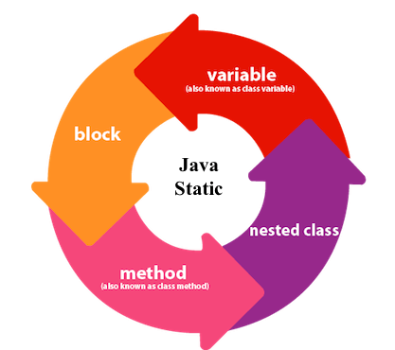
Java Variable
The implementation of a static variable is shown here. The basic concept of a static variable is that it has a single reference variable.
In this way, the utilization of such variables should be possible to keep up a basic count of created objects or objects that access a class.
Example 1:
public class TestStatic {
private static int staticVariable=0;
public static int getStaticVariable() {
return staticVariable;
}
public static void setStaticVariable(int staticVariable) {
TestStatic.staticVariable = staticVariable;
}
}
public class App {
public static void main(String[] args) {
System.out.println("Current variable value: "+TestStatic.getStaticVariable());
TestStatic.setStaticVariable(1);
System.out.println("Current variable value: "+TestStatic.getStaticVariable());
TestStatic.setStaticVariable(24);
System.out.println("Current variable value: "+TestStatic.getStaticVariable());
}
}
Output:
Current variable value: 0
Current variable value: 1
Current variable value: 24
The following code creates a variable instituteName static, it shows that the variable will allocate the memory only once and assign the value ‘IIT Delhi’ for all the objects of the Student class.
Example 2:
class Student {
private Integer id;
private String name;
private static String college = "IIT Delhi";

public Student(Integer id, String name) {
this.id = id;
this.name = name;
}
}
public class TestStaticVariable1 {
public static void main(String args[]) {
Student s1 = new Student(111, "Karan");
Student s2 = new Student(222, "Aryan");
}
}
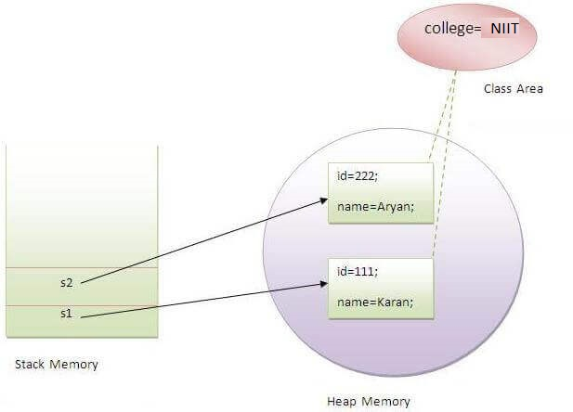
Collage=IIT Delhi
Java Static Method
If you apply the static keyword with any method, it is known as a static method.
- A static method belongs to the class rather than the object of a class.
- A static method can be invoked without the need for creating an instance of a class.
- A static method can access static data member and can change the value of it.
Why is the Java main method static?
It is because the object is not required to call a static method. If it were a non-static method, JVM creates an object first then invokes the main() method that will lead the problem of extra memory allocation.
Java Static Block
It is used to initialize the static data member.
It is executed before the main method.
Example 3:
class A2{
static{System.out.println("static block is invoked");}
public static void main(String args[]){
System.out.println("Hello main");
}
}
Output: static block is invoked
Hello main
Can we execute a program without main () method?
Ans) No, one of the ways was the static block, but it was possible until JDK 1.6. Since JDK 1.7, it is not possible to execute a Java class without the main method.
Example 3:
class Singleton {
private static Singleton singleton;
String databaseNames[] = { "database1", "database2", "database3" };
String selectedDatabaseName;

private Singleton() {
System.out.println("Object Created");
selectedDatabaseName = databaseNames[0];
}

public static Singleton getInstance() {
singleton = (singleton != null) ? singleton : new Singleton();
return singleton;
}

public boolean changeDatabase(String databasename) {

switch (databasename) {
case "database1":
selectedDatabaseName = databaseNames[0];
return true;
case "database2":
selectedDatabaseName = databaseNames[1];
return true;
case "database3":
selectedDatabaseName = databaseNames[2];
return true;
default:
return false;
}
}

public String selectedDatabaseName() {
return selectedDatabaseName;
}
}

public class Test {
public static void main(String[] args) {
Singleton singleton1 = Singleton.getInstance();
System.out.println(singleton1.selectedDatabaseName());
Singleton singleton2 = Singleton.getInstance();
System.out.println(singleton2.selectedDatabaseName());
Singleton singleton3 = Singleton.getInstance();
System.out.println(singleton3.changeDatabase("database3"));
System.out.println(singleton3.selectedDatabaseName());
Singleton singleton4 = Singleton.getInstance();
System.out.println(singleton4.selectedDatabaseName);
}
}
Final Variable
The final keyword in Java is used to restrict the user. The java final keyword can be used in many contexts. Final can be:
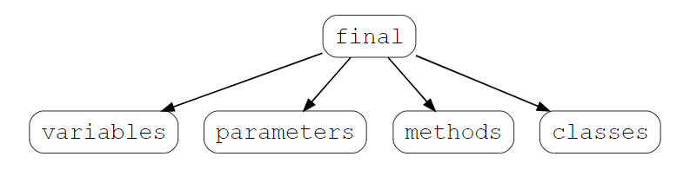
If a variable is declared with the final keyword, its value cannot be changed once initialized. Note that the variable does not necessarily have to be initialized at the time of declaration.
Example 1:
// declaring a final variable
class FinalVariable {
public void pro(){
final int var = 50;
var = 60 // This line would give an error.
}
}
The main difference between a static and final keyword is that static is a keyword is used to define the class member that can be used independently of any object of that class. The final keyword is used to declare, a constant variable, a method that can not be overridden, and a class that cannot be inherited.

